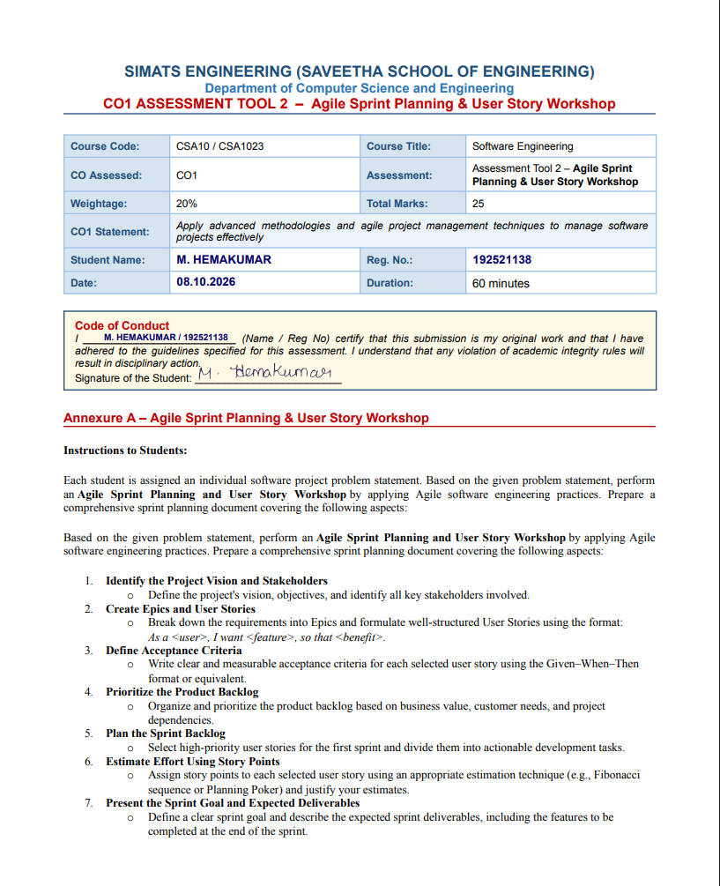
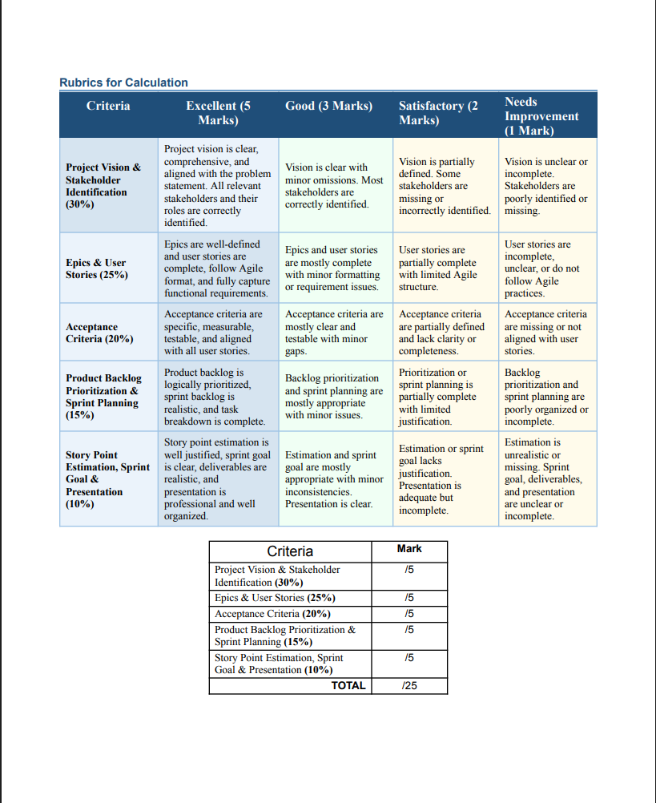
QUESTION 13
Green CI/CD Optimization and Intelligent Build Scheduling Platform
1. Project Vision and Stakeholders
Project Vision
The Green CI/CD Optimization and Intelligent Build Scheduling Platform is designed to make software development and delivery more efficient, resource-conscious, cost-effective, and sustainable.
The platform analyzes CI/CD pipelines and identifies redundant builds, unnecessary test execution, inefficient workload scheduling, and excessive resource consumption. It intelligently selects relevant tests, schedules workloads efficiently, monitors resource usage, and provides sustainability and pipeline-efficiency reports while maintaining required security and quality gates.
The platform aims to optimize software delivery without reducing software quality or increasing release risk.
Project Objectives
- Analyze CI/CD execution and resource consumption.
- Identify redundant builds and unnecessary test execution.
- Optimize test selection based on software changes.
- Schedule CI/CD workloads efficiently.
- Monitor energy and infrastructure indicators where available.
- Maintain security and quality gates.
- Generate sustainability and pipeline-efficiency reports.
Key Stakeholders
Stakeholder | Role and Responsibility
Product Owner | Defines requirements, business value, and priorities
DevOps Engineer | Manages CI/CD pipelines and build scheduling
Software Developer | Develops code and fixes identified issues
QA/Test Engineer | Designs, executes, and validates tests
Project Manager | Monitors project progress, risks, and delivery
System Administrator | Manages infrastructure and computing resources
Security Team | Maintains security controls and quality gates
Sustainability Manager | Monitors resource and sustainability indicators
Management | Evaluates cost, efficiency, and business benefits

2. Epics and User Stories
Epic 1 – CI/CD Pipeline Analysis
US1 – Pipeline Monitoring: As a DevOps Engineer, I want to monitor CI/CD pipeline executions, so that I can identify inefficient pipeline activities.
US2 – Redundant Build Detection: As a DevOps Engineer, I want to identify redundant builds, so that unnecessary computing resources are not consumed.
Epic 2 – Intelligent Test Optimization
US3 – Intelligent Test Selection: As a QA Engineer, I want the system to select relevant tests based on code changes, so that unnecessary tests can be avoided while maintaining software quality.
US4 – Test Result Monitoring: As a Developer, I want to view test execution results and failure trends, so that I can identify quality problems quickly.
Epic 3 – Intelligent Build Scheduling
US5 – Build Scheduling: As a DevOps Engineer, I want to schedule CI/CD workloads efficiently, so that infrastructure resources are used effectively.
US6 – Pipeline Efficiency Dashboard: As a Project Manager, I want to view pipeline efficiency metrics, so that I can monitor development and delivery performance.
Epic 4 – Sustainability Monitoring
US7 – Resource and Energy Monitoring: As a Sustainability Manager, I want to monitor resource and energy indicators, so that I can measure the environmental impact of software delivery.
US8 – Sustainability Reporting: As a Management User, I want to generate sustainability reports, so that I can evaluate improvements in resource efficiency.
3. Acceptance Criteria
User Story | Given–When–Then Acceptance Criteria
US1 – Pipeline Monitoring | Given CI/CD pipeline execution data is available, When the DevOps Engineer opens the monitoring dashboard, Then the system should display build, test, deployment status, execution time, and resource information.
US2 – Redundant Build Detection | Given multiple CI/CD builds have been executed, When the system analyzes build history, Then it should identify builds that perform unnecessary repeated work.
US3 – Intelligent Test Selection | Given a developer has modified specific application modules, When a CI/CD pipeline is triggered, Then the system should identify and execute the relevant tests associated with the changed modules.
US4 – Test Result Monitoring | Given automated tests have completed, When the Developer opens the test dashboard, Then the system should display passed, failed, and skipped tests along with failure trends.
US5 – Build Scheduling | Given multiple CI/CD workloads are waiting for execution, When the scheduler evaluates workload priority and available resources, Then it should assign workloads to suitable resources efficiently.
US6 – Pipeline Efficiency Dashboard | Given sufficient pipeline execution data is available, When the Project Manager opens the dashboard, Then the system should display pipeline duration, resource usage, build efficiency, and test efficiency.
US7 – Resource and Energy Monitoring | Given infrastructure resource information is available, When CI/CD activities are executed, Then the system should record and display available resource and energy indicators.
US8 – Sustainability Reporting | Given pipeline and resource-consumption data has been collected, When the Management User requests a report, Then the system should generate a sustainability and pipeline-efficiency report.

4. Product Backlog Prioritization
Priority | ID | Product Backlog Item | Story Points | Business Value | Dependency
P1 | US1 | CI/CD Pipeline Monitoring | 5 | Very High | None
P1 | US2 | Redundant Build Detection | 5 | Very High | US1
P1 | US3 | Intelligent Test Selection | 8 | Very High | US1
P2 | US5 | Intelligent Build Scheduling | 8 | High | US1, US2
P2 | US4 | Test Result Monitoring | 3 | High | US1
P3 | US6 | Pipeline Efficiency Dashboard | 5 | Medium | US1, US2
P3 | US7 | Resource & Energy Monitoring | 5 | Medium | US1
P4 | US8 | Sustainability Reporting | 3 | Medium | US6, US7

Prioritization Justification
US1 is given the highest priority because pipeline data is required by most other platform features. US2 and US3 are high priority because redundant builds and unnecessary testing directly affect computing efficiency. US5 is prioritized next because intelligent scheduling depends on pipeline and resource information. US6, US7, and US8 are scheduled later because meaningful efficiency and sustainability reports require sufficient execution and resource data.

5. Sprint Backlog
Sprint Duration: 2 Weeks
Sprint 1 Selected User Stories
- US1 – CI/CD Pipeline Monitoring
- US2 – Redundant Build Detection
- US3 – Intelligent Test Selection
- US5 – Intelligent Build Scheduling
User Story | Development Tasks
US1 – Pipeline Monitoring | Design pipeline data model; collect CI/CD data; develop monitoring API; create dashboard; perform testing
US2 – Redundant Build Detection | Collect build history; analyze repeated builds; define detection rules; implement detection logic; validate results
US3 – Intelligent Test Selection | Analyze code changes; map modules to tests; implement test-selection logic; execute selected tests; validate results
US5 – Build Scheduling | Monitor available resources; define workload priorities; develop scheduling logic; assign workloads; test scheduler

Sprint Dependencies
- US1 → US2: Pipeline monitoring provides the data required to detect redundant builds.
- US1 → US3: Pipeline and code-change information is required for intelligent test selection.
- US1 + US2 → US5: Build scheduling requires pipeline execution and workload information.
6. Story Point Estimation
The Fibonacci sequence is used for estimation: 1 → 2 → 3 → 5 → 8 → 13.
User Story | Story Points | Justification
US1 – Pipeline Monitoring | 5 | Requires data collection, API integration, dashboard, and testing
US2 – Redundant Build Detection | 5 | Requires build-history analysis and detection logic
US3 – Intelligent Test Selection | 8 | Requires code-change analysis and mapping changes to relevant tests
US4 – Test Result Monitoring | 3 | Mainly involves collecting and displaying test results
US5 – Build Scheduling | 8 | Requires resource monitoring, priority handling, and scheduling logic
US6 – Efficiency Dashboard | 5 | Requires multiple pipeline and performance metrics
US7 – Resource & Energy Monitoring | 5 | Requires resource and sustainability data collection
US8 – Sustainability Reporting | 3 | Generates reports using existing metrics

Sprint 1 Total: US1 = 5 + US2 = 5 + US3 = 8 + US5 = 8 = 26 Story Points.
The higher estimates for US3 and US5 are justified because intelligent test selection and workload scheduling involve greater technical complexity and dependencies.
7. Sprint Goal and Expected Deliverables
Sprint Goal
“Develop an initial intelligent CI/CD optimization system that monitors pipeline execution, detects redundant builds, selects relevant tests, and schedules workloads efficiently while maintaining software quality and security.”
Expected Deliverables
Deliverable | Description
1. CI/CD Monitoring Dashboard | Pipeline status, build duration, test status, deployment status, and resource usage.
2. Redundant Build Detection Module | Build-history analysis, identification of unnecessary repeated builds, and optimization opportunities.
3. Intelligent Test Selection Module | Changed-code analysis, relevant test identification, automated selected-test execution, and results.
4. Intelligent Build Scheduler | Resource monitoring, workload prioritization, efficient CI/CD scheduling, and reduced unnecessary resource consumption.
5. Initial Efficiency Metrics | Build execution time, test execution time, resource consumption, and pipeline efficiency.
6. Working Prototype | A functional Sprint 1 prototype integrated with CI/CD while preserving required security and quality gates.

8. Definition of Done
- The required functionality is implemented.
- Code review is completed.
- Unit/integration tests are passed.
- Security checks are passed.
- Quality gates are satisfied.
- CI/CD pipeline executes successfully.
- Documentation is updated.
- The feature is demonstrated to the Product Owner.
- No critical defects remain.
9. Sprint Review / Expected Outcome
At the end of the sprint, the team should be able to demonstrate a working prototype that follows this flow:
CI/CD Pipeline → Monitoring → Change Analysis → Test Selection → Build Scheduling → Resource Optimization
The platform should help reduce unnecessary CI/CD computation, improve build and test efficiency, reduce infrastructure resource usage, and maintain software delivery reliability.
10. Final Summary
Item | Final Plan
Project | Green CI/CD Optimization and Intelligent Build Scheduling Platform
Methodology | Agile Scrum
Sprint Duration | 2 Weeks
Total User Stories | 8
Sprint 1 Stories | US1, US2, US3, US5
Sprint 1 Story Points | 26
Estimation Technique | Fibonacci Sequence
Main Goal | Optimize CI/CD builds, tests and scheduling
Main Deliverables | Monitoring, redundant-build detection, test selection, scheduling
Quality Control | Testing + Security + Quality Gates
Expected Benefit | Efficient, reliable and sustainable software delivery

Conclusion
The Green CI/CD Optimization and Intelligent Build Scheduling Platform provides an Agile approach to improving software delivery efficiency. By analyzing pipeline execution, detecting redundant builds, intelligently selecting tests, and scheduling workloads based on available resources, the platform can reduce unnecessary computation while maintaining software quality, security, reliability, and sustainability. The proposed Sprint 1 delivers the core functionality required to build the foundation for further optimization and sustainability reporting.

